Electronic music documentations, practices and models

|  |  |  |  |  |  |
| --- | --- | --- | --- | --- | --- |
| Serge Lemouton | Alain Bonardi | Laurent Pottier | Jacques Warnier |  |  |
| IRCAM  serge.lemouton@ircam.fr | CICM – Paris 8  alain.bonardi@gmail.com | CIEREC – Université Jean Monnet  laurent.pottier@univ-st-etienne.fr | CNSMDP  jwarnier@cnsmdp.fr |  |  |

ABSTRACT

*The documentation*

1.Introduction

Anyone whose job it is to replay electronic music with computer technologies knows the important question of documentation. Each particular piece of music has particular documentation. To interpret electronic music, a computer music designer has to read the score, as well as a technical sheet, a “Readme” document, a user manual. He can also listen to recordings, watch videos, look at drawings, graphics and photos. Having a phone call with the computer music designer who played the piece the last time is likely to help. The job of a computer music designer is a global interpretation of an ensemble of disparate documents.

Firstly, we have to quickly find how to start the “patch” in the documentation. Secondly, we must refer to the documentation and recordings to find out how the music should sound. Thirdly, because of functional obsolescence, documentation has to answer to the question: “what do we do when it stops working?”.

We will see in this paper how historical pieces of music which were well documented enable anyone to play them from scratch, without prior knowledge. For example, the documentations that were realized by Marc Battier at IRCAM between 1991 and 2002, called “cahiers d’exploitation” and “cahiers d’analyse” are good examples of precise descriptions of how a piece should sound and how it is made to sound like this. Nowadays, the Sidney Database at IRCAM offers a model of an environment allowing collective contribution to electronic music conservation.

Considering day to day practices, we realize that electronic music documentation is not an object of study collectively taken into account. It’s yet a real subject for our music preservation.

2.User manual and musical scores

In the transmission of Western music tradition, the score plays a central role. To play a classical or modern instrumental, orchestral or vocal piece, usually the score is sufficient (except maybe for medieval or early baroque music). Everything gets a little bit more complex when we want to perform a musical work involving an electroacoustic part: several other documents are required, usually not included in the score.

To play such a work, the performer can use different types of information found in numerous kinds of documents such as a “Readme” text file, User Manuals, Technical Riders, audio or video recordings, photos, pictures, drawings, scores or even oral transmission. Structured and complete documentation of the pieces are very seldom found in this repertoire.

Unlike a conventional score, whose medium is paper, the information required to perform works involving recent technologies make use of several kinds of media data storage.

In the absence of a standardized score for this musical genre, the question of a faithful transmission of the repertoire, allowing the possibility to play the music in a historically informed way and to preserve it for the posterity is not so easy to answer. As of today, the transmission of this repertoire depends highly on the knowledge of the performers/computer music designers that are able to interpret these disparate elements. They also know how the music “should sound”, but this knowledge is not easy to transmit.

As the electroacoustic repertoire has now arrived at the age of reason, we think that it is now time to propose a documentation model equivalent to traditional musical notation. This documentation should be sustainable because we have seen that for data preservation over time paper always seems to be a better solution rather than digital archives, that cannot always guarantee physical integrity or content intelligibility.

The goal of this research is to examine the practices in term of notation and transmission of the contemporary works electroacoustic part, in order to spot emerging consensus on good practices. In a second time, we will be able to propose a more standardized model emerging from these disparate documentation models, in order to find a common language for the transmission of this repertoire. As of the traditional musical notation, this language should be also useful for the creation of new works.

3.Documentation’s historic   
models

3.1 Classic works of the electronic repertoire

Karlheinz Stockhausen was one of the most famous composers and pioneers of electronic music. He was also a composer who has detailed his approach and often fully documented each sound he produced to realize his electronic works. For example, the piece *Studie II* (1954) has been described both by mathematical formulas producing the (non-harmonic) relations between the partials composing each of the sounds, and by precise diagrams of the amplitude and register envelopes, which later allowed researchers to reconstruct the piece with software such as Max/MSP [1] or Csound [2]. However, the technique used by Stockhausen wasn’t digital, with the use of tape recorders and long reverberations to mix sounds, which gave them a particular timbre that is relatively difficult to achieve with digital technologies. The new versions of *Studie II* don’t sound exactly like the original, made of clearer, more precise sounds. Do the results perceived by the listener with these new versions correspond to what the composer expected half a century before?

In the field of computer music production, John Chowning has produced several well-known pieces, including *Turenas* (1972) in which he implemented two major innovations he had recently theorized: frequency modulation synthesis and spatialization of sounds. Made exclusively by synthesis, with the Music IV program provided by Max Mathews’ research, *Turenas* also used high level composition functions, routines used to generate whole sets of sounds, according to arithmetic, random or combinatorial processes. Until the end of the 20th century, *Turenas* was only documented by the sketches produced by the composer. It is only recently that John Chowning was able to hand over all the files that had been used to produce the piece. Since the Music IV program is well documented (see Max Mathews’ Music V [3]), these files give precisely the structure of each of the synthesis instruments used to produce the sounds, as well as the parameters of each of the sounds produced by these synthesizers. Thus, it is now possible to reproduce exactly all the sounds of the piece and synthesize them entirely with these data, using for example the Csound or the Max programs [4]. However, John Chowning also produced other files showing how each type of file was produced and what compositional processes were used to make timbre interpolation or to move sounds into space, and so on. The documentation is therefore available at two levels : sound synthesis and composition. A live arrangement of the piece was also made in 2011 to allow four percussionists to perform *Turenas Live* from a score and real-time gesture devices [5]. Different versions (2011-2016) of *Turenas Live* are now available on IRCAM's Sidney website.

3.2 Interactive music

The previous examples are very special cases and quite rare. In the case of interactive music, the situation is more complex. There are electronic instruments for synthesizing and processing sounds that need to be documented, but how to play and control these instruments should also be documented. Real-time technologies are more breakable than others.

The case of the French composer Kasper T. Toeplitz is rather particular. The various pieces he has composed as interactive mixed music or purely electronic real-time music are all fully noted on graphic and textual scores. They give no information on the DSP techniques necessary to produce or process sounds, they only indicate the sonic results to be produced, indicating the progression of time and the acoustic characteristics of the sounds to be produced. It is up to the instrumentalists to build their own instruments (usually using the Max program) and to play with them in concert. This assumes musicians have good programming skills, and are able to understand the composer's language and instructions. In fact, Kasper T. Toeplitz works regularly with the same performers. It might be interesting to make these scores available to uneducated performers to appreciate what music could be produced with them.

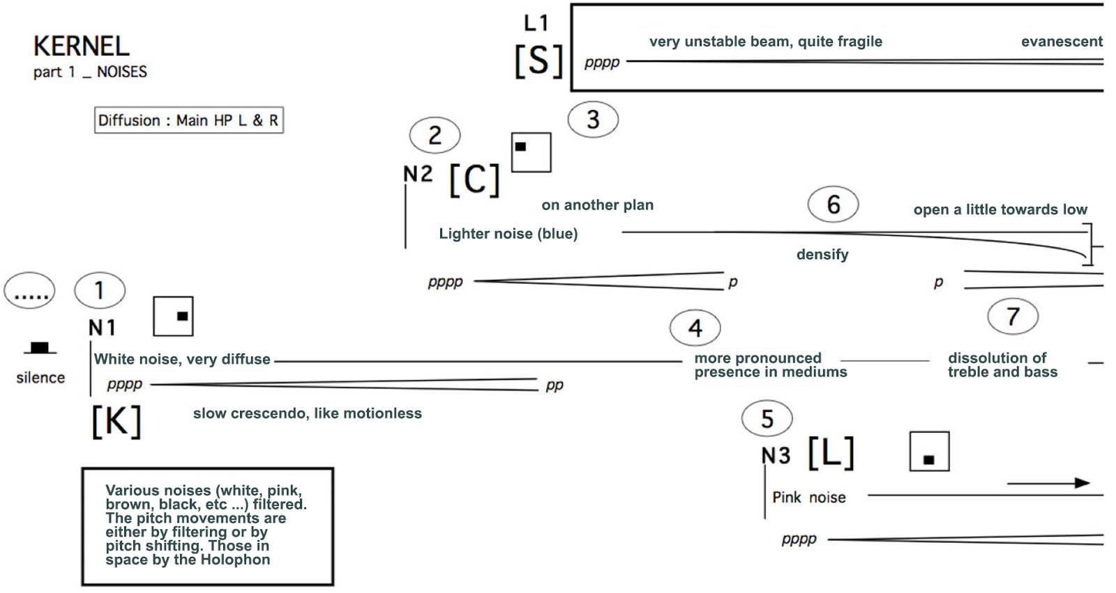

**Figure 1.** First page of *Kernel* score (Kasper T. Toeplitz, 2002).

In electronic music, many musicians use the Ableton Live program. How long can works made with this program, the sources of which are unknown, be played again? In questioning the French musician Alexandre Augier, we see that this problem is a major concern. He works simultaneously with Live, Max, Processing, Madmapper and an analog synthesizer based on Linix. If the settings of the analog synthesizer are easily preserved by photos or connections, made using the Modular Grid site (see Fig. 2), the software part is much more complex to preserve. For each version of a piece, a document is written including a diagram of connections (see Fig. 3), a checklist and indicating the versions of each software used. The computer’s operating system (Mac OSX) is updated as rarely as possible (long time remained in 10.6.8 and now in 10.10). Despite this, with the latest version of Max, some external objects are no longer recognized depending on 32 and 64 bits option. All older versions of the software (Max and Live) are archived on an external drive.

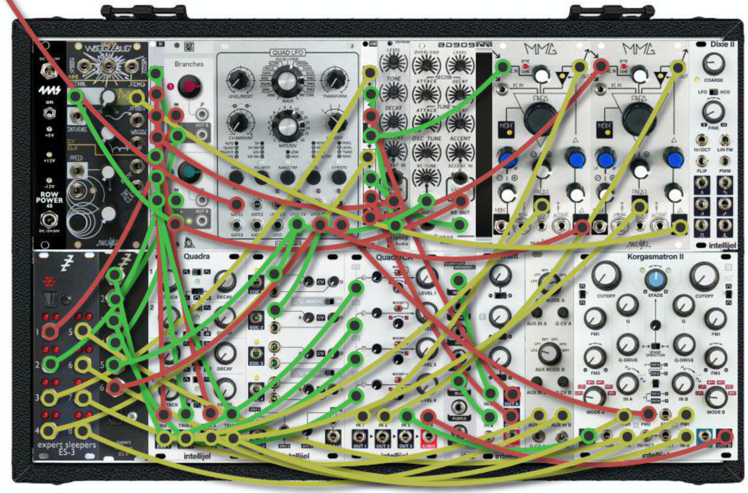

**Figure 2.** Graphical backup of the Linix synth patch in *_nybble* (Augier, 2017)

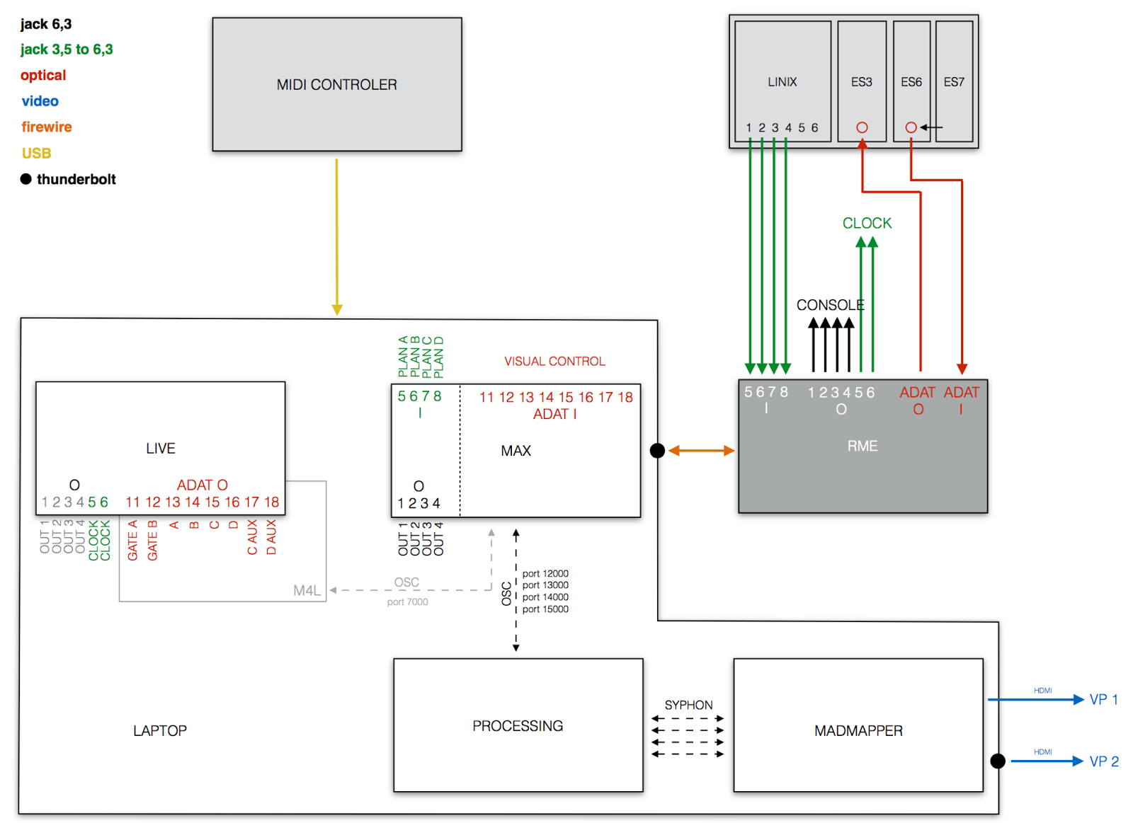

**Figure 3.** Software and hardware configuration of *_nybble* (Augier, 2017)

In interactive music produced with Max, is it possible to program patches that are sufficiently well documented so that screen copies allow both to know exactly how the DSP scheme works and how the settings should be made on different parts of the piece so that they can be reprogrammed easily from scratch and we get the desired result?

For example the patches made for the Tana String Quartet, for *Smaqra* (Juan Arroyo, 2015 [6]), a piece in which there is not any computer music designer present during the concerts, all electronics are managed only by the musicians without any intervention in Max. The musicians must, however, know the precise DSP operation made by the program; the program was designed in such a way that all the features are clearly documented as much as possible.

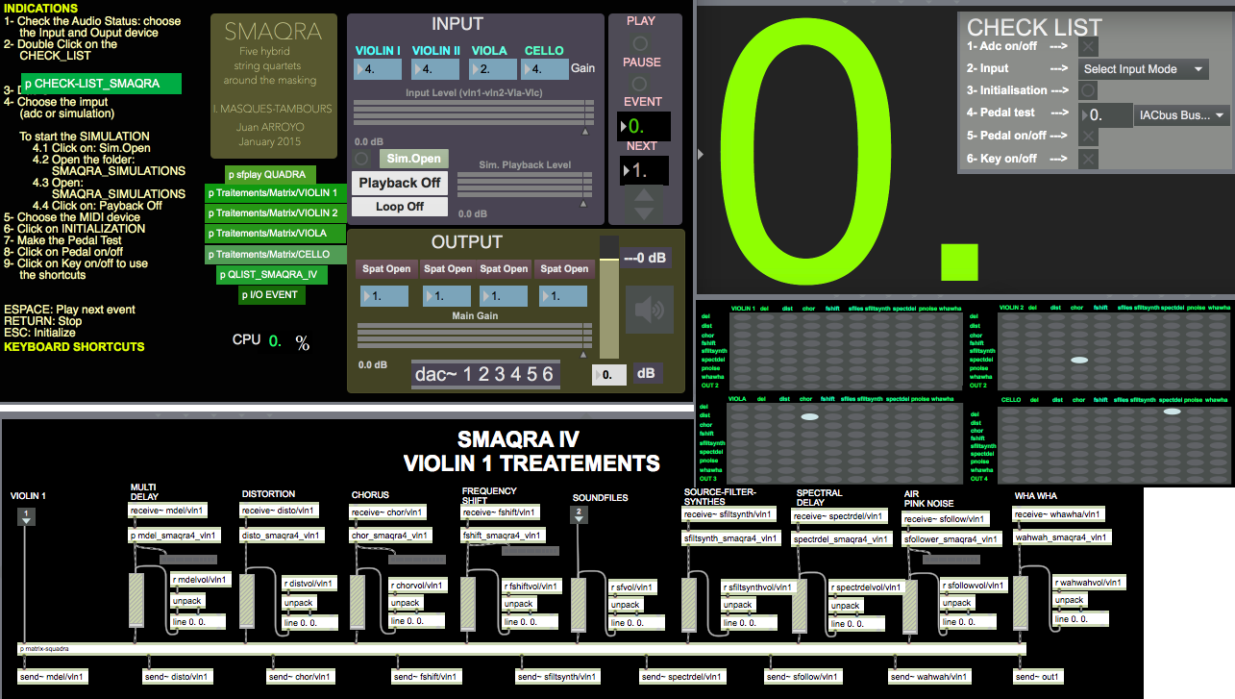

**Figure 4.** The main window of the *Smaqra* patch for hybrid string quartet  (Arroyo, 2015)

3.3. French creation studios (CNCM)

A recent study conducted around the French National Centers for Music Creation (GRAME-Lyon, GMEM-Marseille, CIRM-Nice, Césaré-Reims, La Muse en circuit-Paris-Alfortville, SCRIME-Bordeaux) showed that there is no concerted action and no rigorous practices for the long-term preservation or documentation of live computer music. The length of composers’ residencies for a creation is often short (a few weeks) which does not leave any time for documentation. As a general rule, files are saved, works are recorded, sometimes filmed, electronic parts are sometimes recorded separately as audio files. The trend is to avoid closed commercial tools for real-time works, and limit themselves to standard objects (for Max patches).

The question of the backups concerns the problem of the programs’ DSP architecture, the management of the events (triggering, presets, score following), and the interfaces for gestural controls.

A few years ago, however, the national research agency in France (ANR) funded several research projects to find solutions to this question.

4. Ircam repertoire

4.1. Documentation in previous preservation projects

The Mustica Research Initiative was an international project led and coordinated by the University of Technology of Compiègne, built on a collaboration between two contemporary music institutions (IRCAM and GRM/INA), by performing research on the topic of contemporary music preservation between 2003 and 2004 [7][8]. At the end of October 2006, the project had catalogued 54 references concerning IRCAM works. It provided access to many sources of information: a PDF documentation generated on the fly (including the main patch, the loudspeaker implementation, the audio-MIDI setup), audio excerpts generally in MP3 format, pages in the BRAHMS database about the composer and the work, various publications and a possibility of purchasing the CD.

The ASTREE project (Analysis and Synthesis of Real-Time Sound Processing, 2009-2011) brought together IRCAM, GRAME, Armines/CRI, and CIEREC (University of Saint-Etienne) and focused on the elicitation of live electronic processes using the Faust language developed by GRAME since 2000, the generation of documentation, and the constitution of knowledge based on these processes. It provided the opportunity to create Faust code and documentation for *Turenas* by John Chowning (1972) and *En Echo* by Philippe Manoury (1993) [9]. The generated documentation mainly consists of the elicitation of the live sound processes. With a basic knowledge in mathematics, anyone can regenerate the electronic sound transformations although temporal control values are not represented. In a way, it can be included in the musical score to indicate the content of electronics.

4.2. “Les cahiers d’exploitation”

From 1991 to 2002, the musical pieces commissioned and realized in IRCAM studios were documented by Marc Battier. He wrote these manuals in collaboration with the musical assistants responsible for the realization of each work. These booklets were called “cahiers d’exploitation”, 100 IRCAM-commissioned works where documented this way.

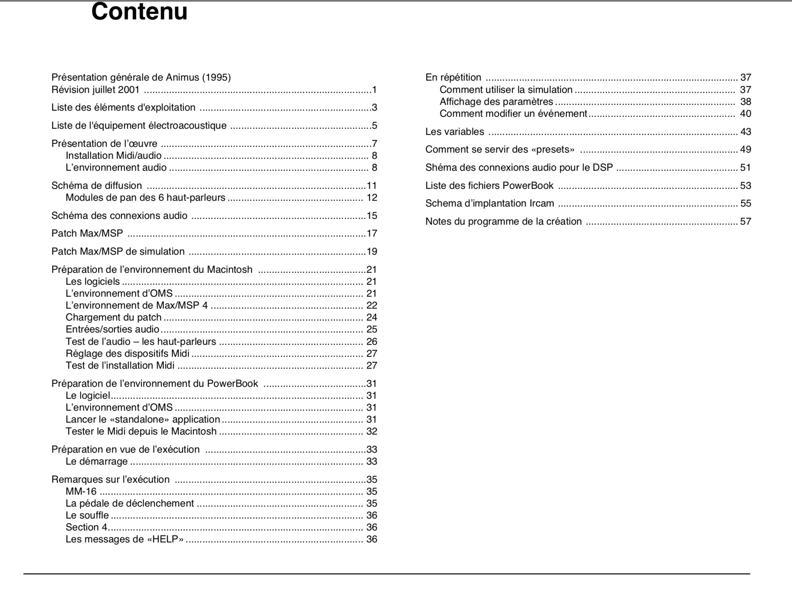

**Figure 5.** A typical “cahier d’exploitation” table of content.

As implied by the title of these documents (“cahiers d’exploitation”), they contained all the information required to perform the pieces. During the same period, a few musical works have been documented in a more detailed way in so-called “cahiers d’analyse”. These documents contained some interesting details about the creative process behind the production of a work (computer assisted composition systems, design of the interactive part, score followers, esthetic or theoretical considerations, etc.).

4.3. Sidney

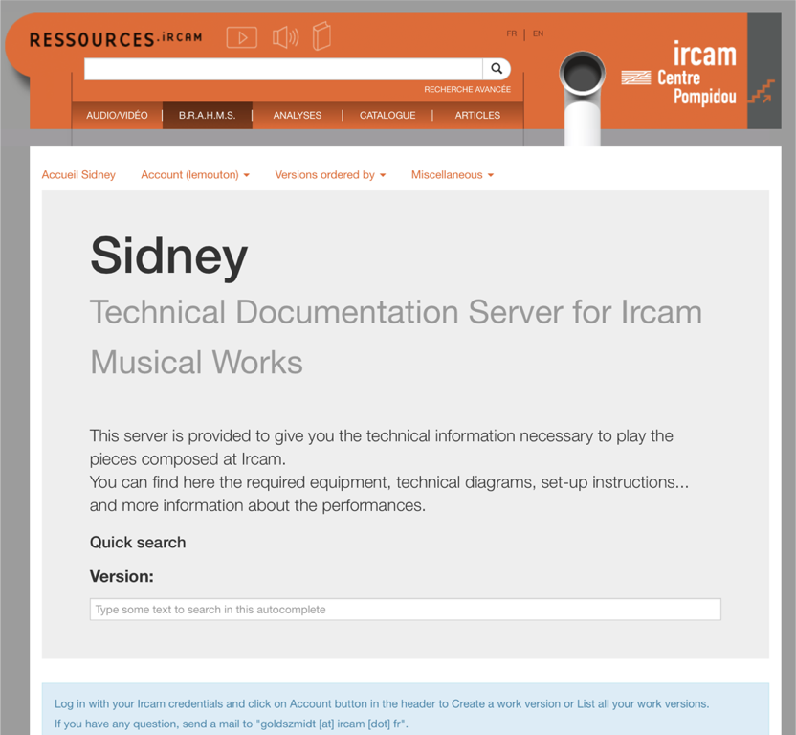**Figure 6**. *Sidney* home page.

Sidney is the name of the online database used in the IRCAM production department to store all the elements required to perform the institute repertoire pieces [10].

Sidney is a part of the Brahms database (www.brahms.ircam.fr) which intends to document all contemporary music since 1945. Sidney contains data about almost every work created at IRCAM. Its goal is to archive and to document the technological part of all IRCAM electro-acoustic pieces; from the technological state of the work when it premiered to its latest public performance. The main concept is the “work version”: the idea is not only to document every work but every “version” of the work. As we are in a technological context, evolving at a very fast pace, it is not possible to preserve a work as such, simply because each new performance with real-time or interactive systems requires updates or modifications. The “musical work” object is stored in the Brahms database, while each "version” object is stored in Sidney (inheriting from Brahms content).

The main technology used for the development of the Brahms site is the Django Framework [[https://www.djangoproject.com](https://www.djangoproject.com/)].

The data are structured in a MySQL database, through the Object Relational Mapping provided by Django. The underlying data model is shown in Figure 7.

**Figure 7.** The *Sidney* data model

The Sidney model has been proven to be effective enough to be adopted by almost every IRCAM computer music designer. The whole community uses it systematically to document and to store the patches after every new performance. It is a kind of archive, every successive version of the work is kept, it is also a digital repository for the performance material of contemporary mixed music repertory.

The target users of this site include all the contemporary music actors: computer music designers, composers, publishers,  producers, concert organizers, sound engineers, scholars, students … Each time a concert organizer desires to program a piece created at IRCAM, he will ask us the list of required material: with Sidney it is easy to answer these requests quickly. The documentation in Sidney can be created in a relatively free way.

During the system design, the decision was taken not to put too many constraints or verifications on the way to enter data. The idea was to make data ingestion an easy and fast task. Before being marked as “valid” (potentially available for distribution outside of IRCAM), a version can go through the following states:

·   unknown

·   archive

·   in progress

·   documented

·   valid

The validation phase, done *a posteriori*, is essential to verify that all the information required for proper documentation is provided. When a version has been validated it means that the work is ready for exploitation at the time of the validation and for a duration depending on the too fast evolution of the technologies involved.

The estimation phase consists of an evaluation of the resources required to update a piece that is no longer exploitable in its current state.

A documentation charter exists (in permanent evolution), given to each Sidney user. Every contributor should conform as much as possible to this charter so all the documentation elements are complete, allowing a new performance and possible future porting. This document lists all the elements that should be present in the documentation: instructions, things to be done to play the piece, performance notes, etc.

 **Figure 8**. Charter showing all the information data type that should be present in a valid Sidney documentation

The validation step consists of verifying that the documentation conforms to the different points of the charter.

As of today, there are almost 1000 versions of 550 different musical works documented in Sidney; 122 versions are valid.

Each valid work documentation in Sidney contains detailed written instructions (in English) on how to perform the piece.

This exceptionally large corpus of documented musical works could be an object of study in and of itself.

5. Theoretical considerations

**5.1 Documentation classifications**

The documentation of electroacoustic works is very heterogeneous; it does not consist of only textual documents. We can find drawings, diagrams, tables, sound files, pictures, etc. This heterogeneous nature has some consequences on the possibilities of storage and preservation, it has to be taken in account when designing a digital repository.

The information contained in accompanying documents may be of several natures: what is described can be the composer’s intentions or the result. It can also be a description of the way to realize the work. In other words, the why? the what? or the how?.  
If we make a parallel with traditional music notation, it corresponds in a certain way to the difference between a transcription (a notated description of a musical event) and a tablature (prescribing what to do to produce the music).

To illustrate this dichotomy, we can compare the score of two electronic pieces of the 50s: Ligeti’s *Artikulation*’s score is a “listening score” realized a posteriori (a kind of visual transcription  of the music) while Stockhausen *Studie II* is an extremely detailed description of the way to produce the piece that can even be used to reconstruct it.

The composer’s intentions can be expressed as text (spoken or written), as graphic sketches, more or less precise drawings or music notation. On the final product side, we can find computer code (Csound score files, Max patches, …), sound files, but also musical notation and graphic notations.

The documentation accompanying an electroacoustic work can be either descriptive or prescriptive. It can be a description of how the piece should sound and how it is constructed, or a step-by-step list of instructions telling the electronic musician how to prepare the complete setup and to perform the work. These two categories correspond to the “cahier d’exploitation” and “cahier d’analyse” above mentioned.

We can find performance instructions, in textual or oral form. These instructions, often related to general level, acoustic balance between the layers, actions to be made during the performance, or more esthetic recommendation, can be more or less precise, but are nevertheless always very precious concerning the composer’s intentions.

Less often, instrument specification can be found. A precise description of the content, functionalities and architecture of the Max patch can be very useful to understand its operations, without having to do reverse engineering. Formal, standardized specifications of sound processing modules is highly desirable to facilitate porting and sustainability of the music using such modules.

A huge majority of works in the mixed interactive computer music are programmed in the Max environment. As in any (programming) language, each author has his/her own style. A patch can be more or less readable [11]. Some developers used extensively informative and useful comments inside the patch, but some patches are not auto documented at all. The patch structure can be more or less readable. The difference in the styles of several computer music designer programming in Max can be identified in [10].

A good Max patch can contain its own documentation, and all the step necessary to setup the performance (audio routings, loudspeaker tests, calibrations, etc.) can be directly performed from inside the max patch before the concert. Do we know a Max patch that can be run without any supplementary written or oral explanations, without any contact with the composer or the computer music designer?

The programming of the electronic events can be done in several ways: events can be stored as Max patches or software programs, stored on the computer as more or less readable proprietary file formats, or as text files (such as Max qlists, Csound score or Antescofo score, or other). Text files always seem to be preferable as they can be more easily ported, read and stored. The electronics part of Pierre Boulez’ *Anthèmes 2* was recently reprogrammed from Max patches to Antescofo scores. It was the occasion to make a more readable electronic score, closer to the printed musical score, also the occasion to correct some mistakes ("wrong notes”) that were uneasy to detect in the original Max programs.

A programming environment allowing the visualization of the electronic score in the form of a timeline adds some readability. Such systems fill the gap between the computer score and the musician score. In Figure 9, showing an excerpt of a piece for viola and electronics written by Julia Blondeau ()

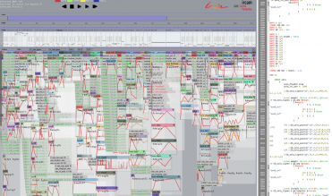

**Figure 9**. Ascograph representation of Julia Blondeau’s *Tesla*.

This representation is more than a visual representation, it is an operational score, in the sense that it can be played by the computer. To have this kind of operational representation of an electroacoustic proves to be really useful to understand, debug and perform the piece.

A very useful element when a mixed work using real-time transformation is received for performance is the presence of an audio recording of the instrument(s) that is(are) transformed. This recording of the acoustic part of the work, called “adc recording” or “simulation” can be used to test the Max patch before the performance, to rehearse the piece without the presence of the musician, and to test the score following system if necessary. It is also a very precious element when the software environment requires porting. The practice of systematically recording the input of a concert Max patch and to distribute this audio recording is highly recommended.

**5.2 What should be done to improve the situation?**

We have seen that proper documentation is crucial for the interpretation, the transmission and for the sustainability of mixed electroacoustic pieces. Since the establishment of this repertoire several practices have emerged. We are now able to identify and classify the different information elements found in works’ documentation. It is now possible to identify what can be considered as good practices, to develop digital data systems to store this information and to propose some methods toward a standardization of such documents. This standardization of computer music notations is an important step in electronic music history.

6. Conclusion and perspectives

Museums put together international groups of research like the International Network for the Conservation of Contemporary Art (<https://www.incca.org>) to gather answers on this subject of cultural heritage. Their aim is to be able to show their collections of contemporary artwork in the future.

A working group called Collaborative Archiving and Creative Preservation (“archivage collaboratif et preservation créative”), gathering several French institutions is supported by the AFIM (Association Francophone d’Informatique Musicale). This working group started its activities in the beginning of 2018. Its goal is to network our ideas and to find the best ways to document the music we play today to be able to play it in the future. The group will also work on the question of long term preservation of the database in reliable digital repositories. It will also have to work on legal issues concerning the rights of collaborative multi-author documents in a techno-artistic context. The main goal of this group is to propose a model and to develop a functional preservation system allowing all the persons concerned by the writing of electronic scores (composers, computer music designers, sound engineers, publishers …) to collaborate on the elaboration of a common shared documentation database.

References

[1] Hajdu G. (2011), *Karlheinz Stockhausen: Elektronische Studie II*.  (<http://georghajdu.de/6-2/studie-ii/>)

[2] Sousa Dias, A. D.  (2007), *Deux contributions à la pédagogie de la musique électroacoustique et de l'informatique musicale*. In Actes des Journées d'informatique Musicale, Lyon, JIM07, Lyon, Grame.

[3] Mathews, M. (1969), *Music V Manual*. In The Technology of Computer Music, Cambridge, MIT Press, p.115-172.

[4] Pottier, L. (2007), *Turenas, Analysis*. In John Chowning, coll. Portraits Polychromes, n°18, Paris, INA-GRM, p. 61-73.

[5] Pottier, L. (2013), *La régénération des sons de Turenas de John Chowning.* In Préserver - Archiver - Re-produire : musique et technologie, jeux vidéo, dir. Evelyne Gayou, Portraits polychromes, Hors série thématique n°21, Paris, INA-GRM, p.145-196.

[6] Maisonhaute, J, (2017), *The Tanacello, a versatile instrument for learning the cello*. In Innovative Tools and Methods for Teaching Music and Signal Processing, dir. L. Pottier, Paris, Presses des Mines, p.187-200.

[7] Douglas, J. (2006). *InterPares2 Project: General Study 03 Final Report: Preserving Interactive Digital Music.* The MUSTICA Initiative.

[8] Bachimont,, B. et al. (2003). *Preserving Interactive Digital Music: A Report on the MUSTICA Research Initiative*. In Proceedings of the Third International Conference on WEB Delivering of Music (WEB’03), Leeds, England.

[9] Bonardi, A. (2013), *Pérenniser pour transmettre, transmettre pour pérenniser - Destins de l'œuvre mixte interactive - Autour de En Echo, pièce de Philippe Manoury*. In Musique et Technologie - Préserver, archiver, re-produire, Portraits polychromes, hors-série thématique, Paris, Institut National de l'audiovisuel, p.105-126.

[10] Lemouton, S. and Goldszmidt, S. (2016). *La préservation des œuvres du répertoire IRCAM : Présentation du modèle Sidney et analyse des dispositifs temps réel.* In Actes des Journées d'Informatique musicale, Albi, GMEA.

[11] Lemouton, S., Bonardi, A. and Ciavarella (2009). *Peut-on envisager une organologie des instruments virtuels de l'informatique musicale ?* In Conference on Interdisciplinary Musicology, Paris.

[12] Fober, D., Bresson, J., Couprie, P., Geslin, Y. (2015). *Les nouveaux espaces de la notation musicale: Groupe de travail AFIM*. In Actes des Journées d'Informatique Musicale, Montréal, Canada.   
(<http://jim2015.oicrm.org/>) <hal-01160759v2〉